Kubernetes with minikube

1.Use the installation guide link given below  
<https://www.c-sharpcorner.com/article/how-to-install-kubernetes-via-minikube-using-windows-10-powershell/>

Run powershell as a administrator  
now use the command:

New-Item -Path 'c:\' -Name 'minikube' -ItemType Directory -Force

Invoke-WebRequest -OutFile 'c:\minikube\minikube.exe' -Uri 'https://github.com/kubernetes/minikube/releases/latest/download/minikube-windows-amd64.exe' -UseBasicParsing

minikube start:

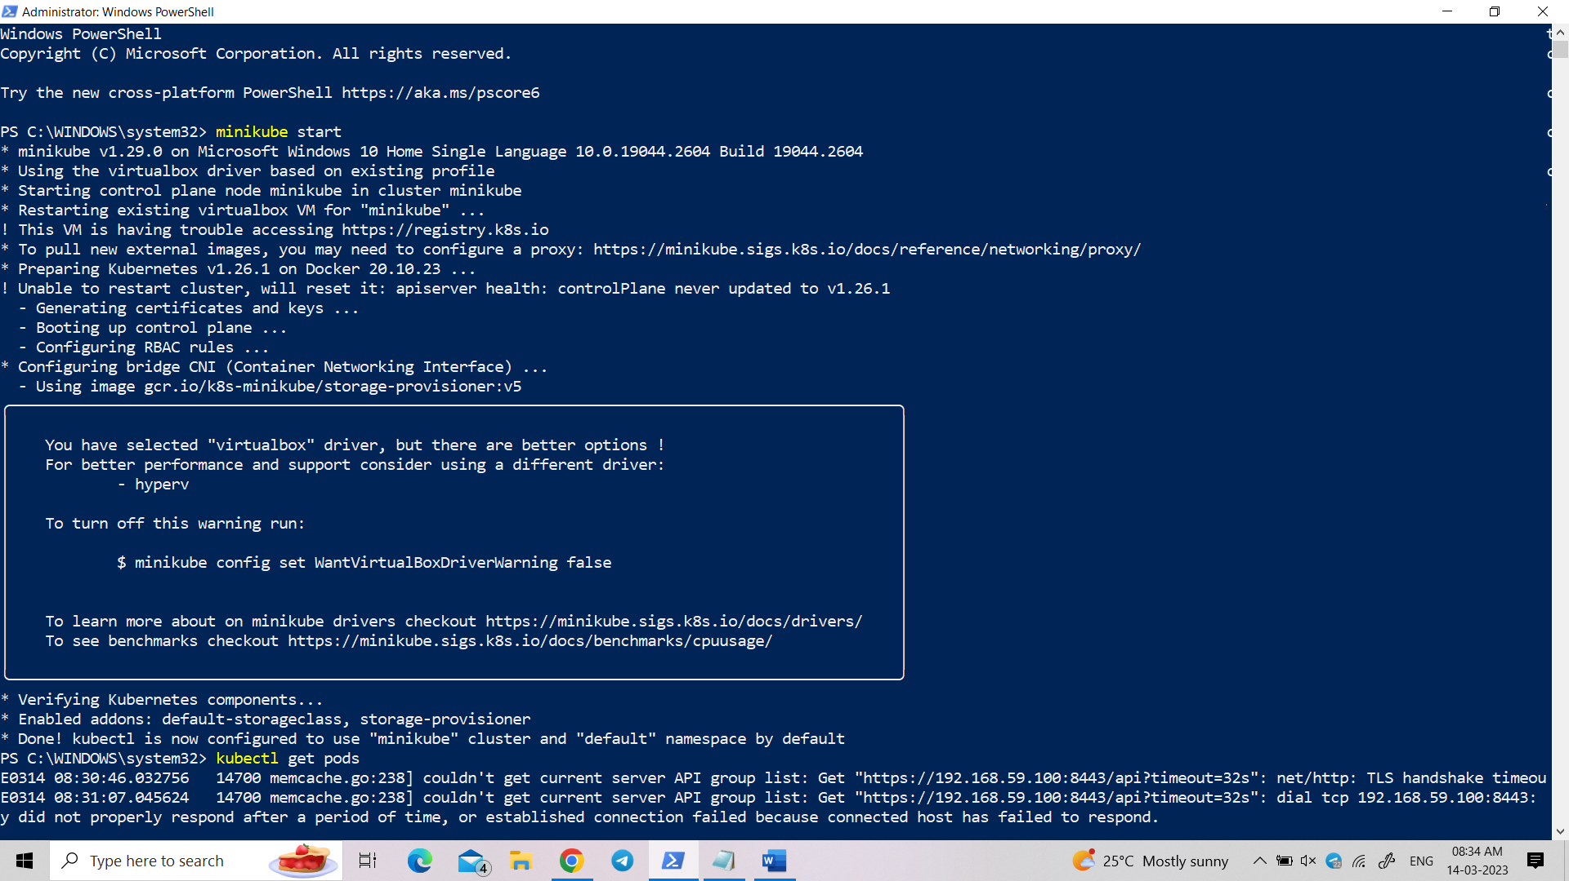

Create directory lab2:

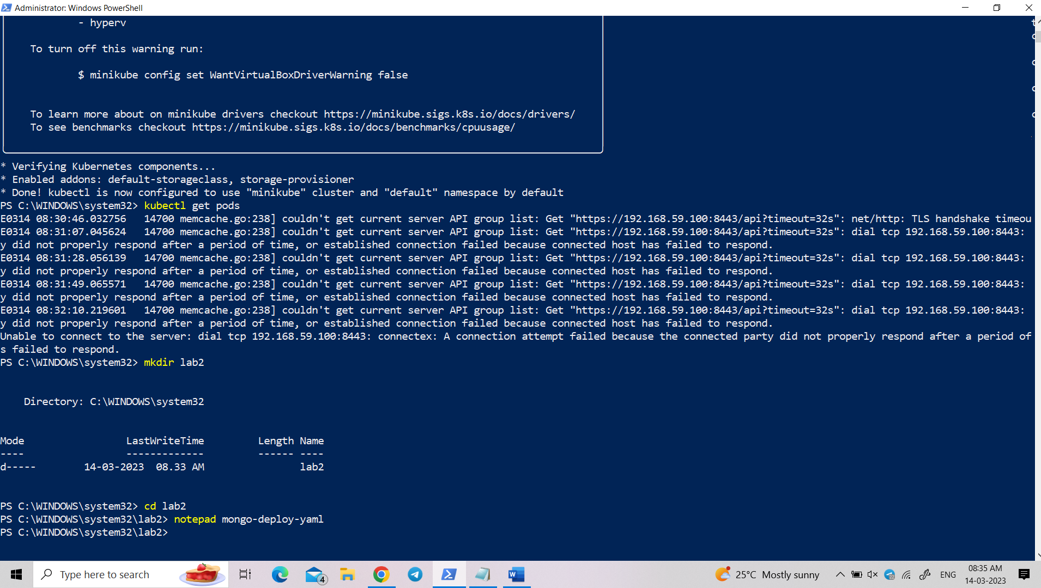

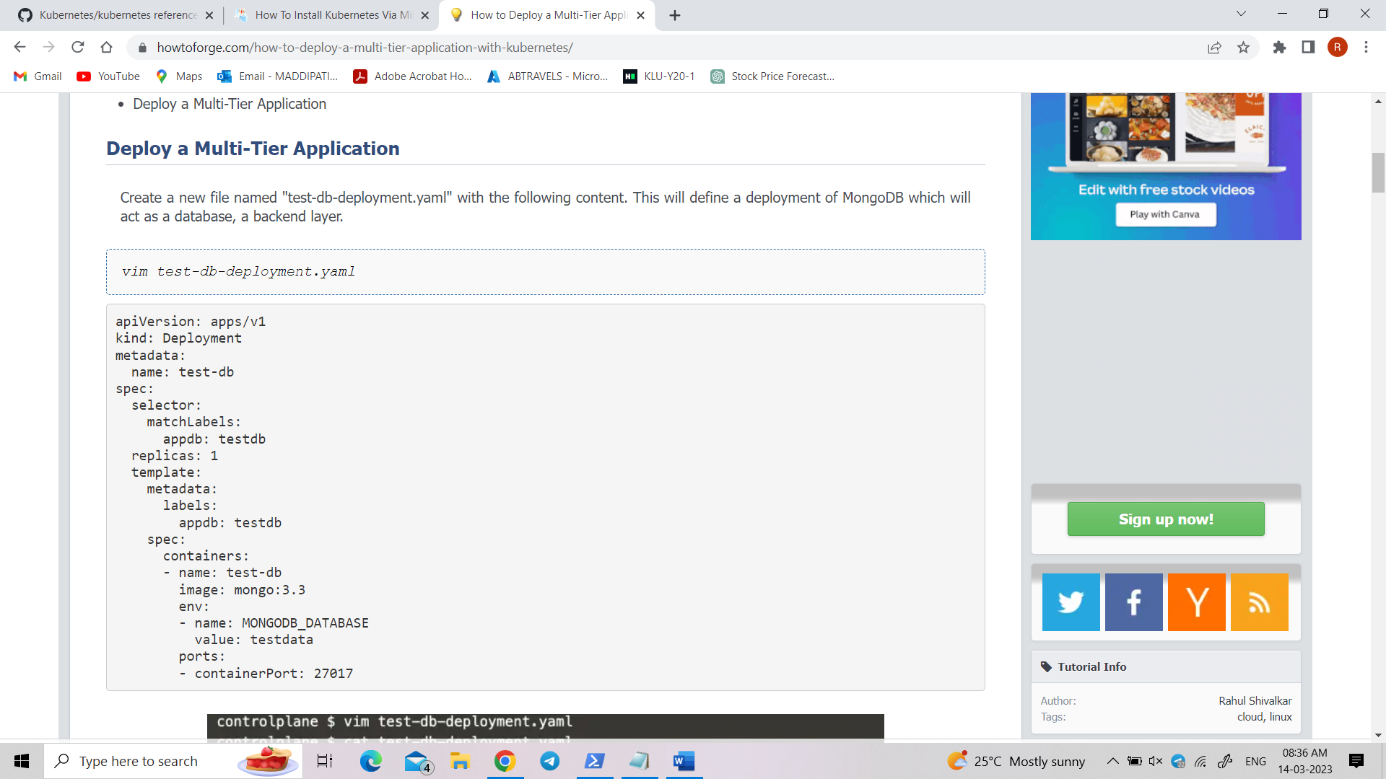

Paste in notepad:

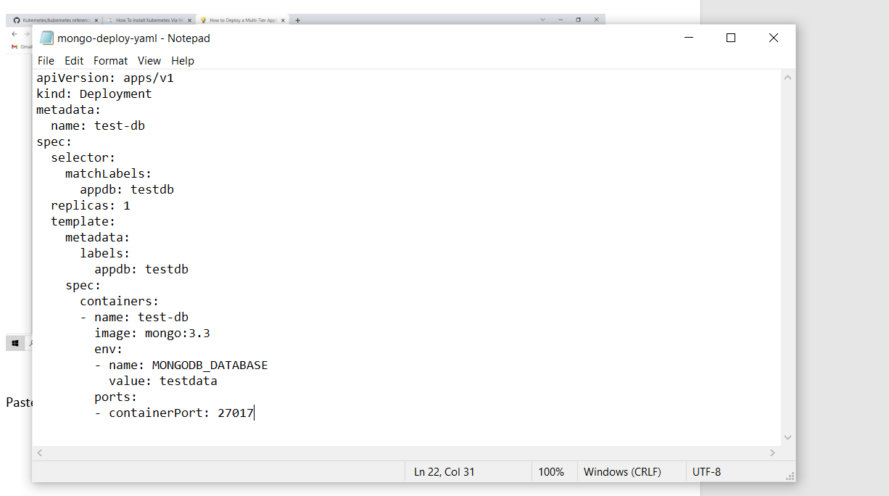

*vim test-db-service.yaml*

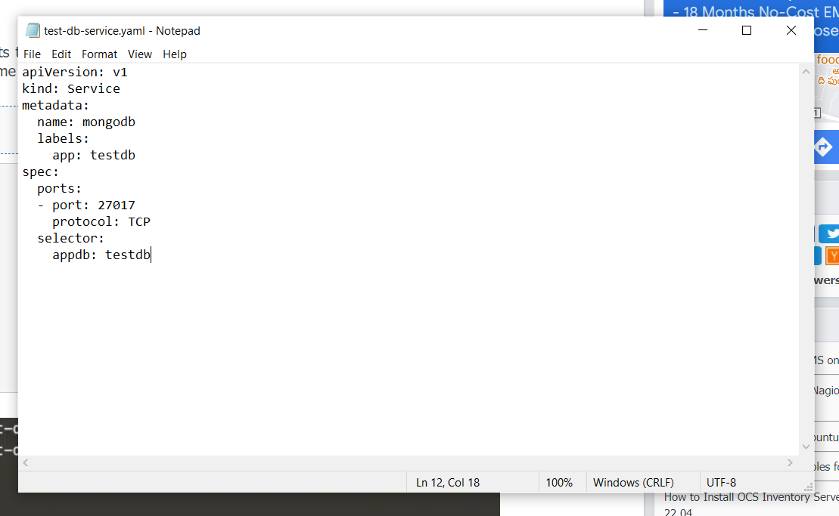

*vim test-web-deployment.yaml*

